*CEE 6110 Assignment #6 Sharing Data on the CUAHSI Hydrologic Information System*

*Karun Joseph*

*A02240287*

Sharing Data on the CUAHSI Hydrologic Information System

Introduction

Hosting and sharing environmental data on publicly accessibly database management system allows easier research collaboration, and requires little technical expertise and initial setup cost. This report demonstrates the use of HydroServer Lite, a lightweight version of CUAHSI HydroServer, as a solution for storing and sharing environmental data.

Methods

Temperature and relative humidity, examples of environmental data, were measured at Room 239, Engineering building, Utah State University in Logan, Utah. The data collection period was 10 minutes for the day 11/2/2016 from 8:40am to 8:49am. A microcontroller board based on the ATmega328P (Arduino UNO (“Arduino - Home” 2016)) performed the data collection. Temperature and relative humidity data were recorded using a digital temperature and humidity sensor (AM2302) with a scan interval of 5s and recording interval of 10s. Fig. 1 shows the instrumentation setup and Table 1, the data collected. A HydroServer Lite (Conner, Ames, and Gill 2013) instance was created on a server hosted by Brigham Young University. The instance had an Observational Data Model (ODM) (Horsburgh et al. 2008)-based physical data model. Attributes of ‘source’, ‘sites’, ‘methods’ and ‘variables’ tables were added. Temperature and relative humidity data values were then manually added into the ‘datavalues’ table through the HydroServer Lite web-browser based client. Fig. 2 shows the site at which the data were collected on a map overlay and Fig. 3, a time series plot of the measured temperature and relative humidity.

Results

The HydroServer Lite web browser-based client allows to search and visualize data hosted on the server. It also exposes the server-hosted data through REST and SOAP web services which enable data retrieval on a client by any programming language.

Conclusions

CUAHSI HydroServer is an effective means to host and store environmental data in a structured manner that are publicly accessible. The HydroServer Lite version is highly efficient as it works across platforms and only requires an internet connection and a web browser. However, this might be a bottleneck as any data analysis and processing would require a responsive server that can handle multiple requests. Overall, this report recommends the use of HydroServer Lite version of CUAHSI HydroServer for hosting and sharing environmental data.

References

“Arduino - Home.” 2016. Accessed November 3. https://www.arduino.cc/.

Conner, Lafe G., Daniel P. Ames, and Richard A. Gill. 2013. “HydroServer Lite as an Open Source Solution for Archiving and Sharing Environmental Data for Independent University Labs.” *Ecological Informatics* 18 (November): 171–77. doi:10.1016/j.ecoinf.2013.08.006.

Horsburgh, Jeffery S., David G. Tarboton, David R. Maidment, and Ilya Zaslavsky. 2008. “A Relational Model for Environmental and Water Resources Data.” *Water Resources Research* 44 (5): W05406. doi:10.1029/2007WR006392.

Appendix A: Figures

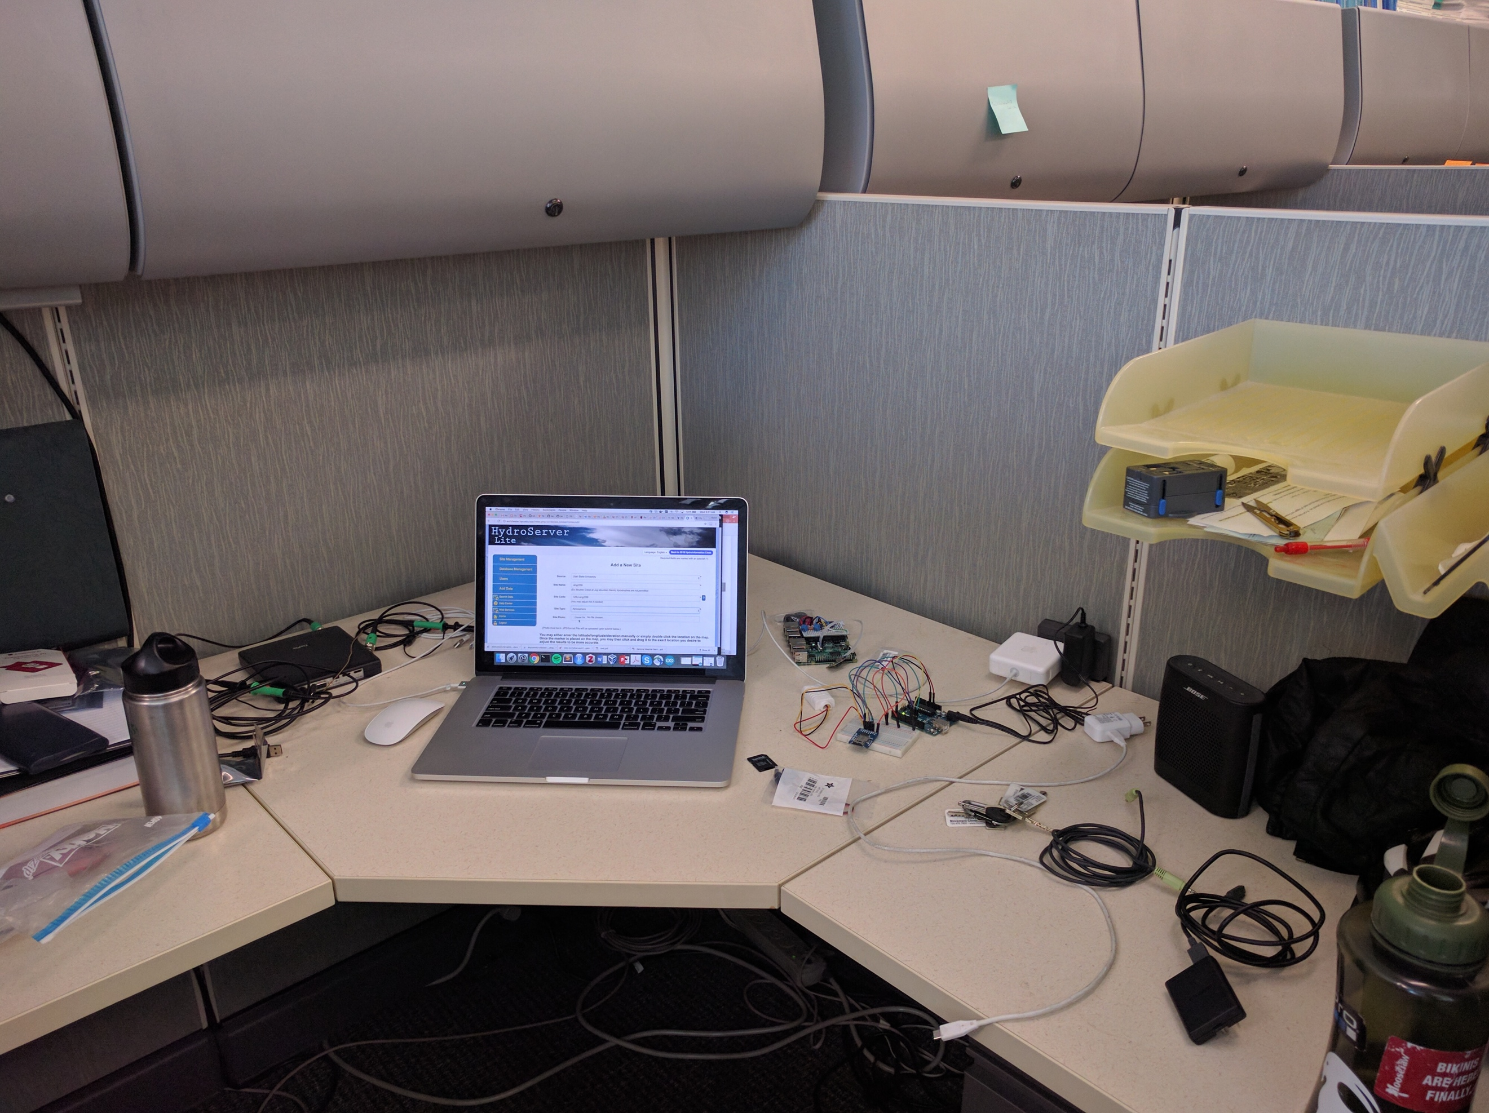

Fig. 1: Data collection site at ENGR 239, Utah State University, Logan, UT

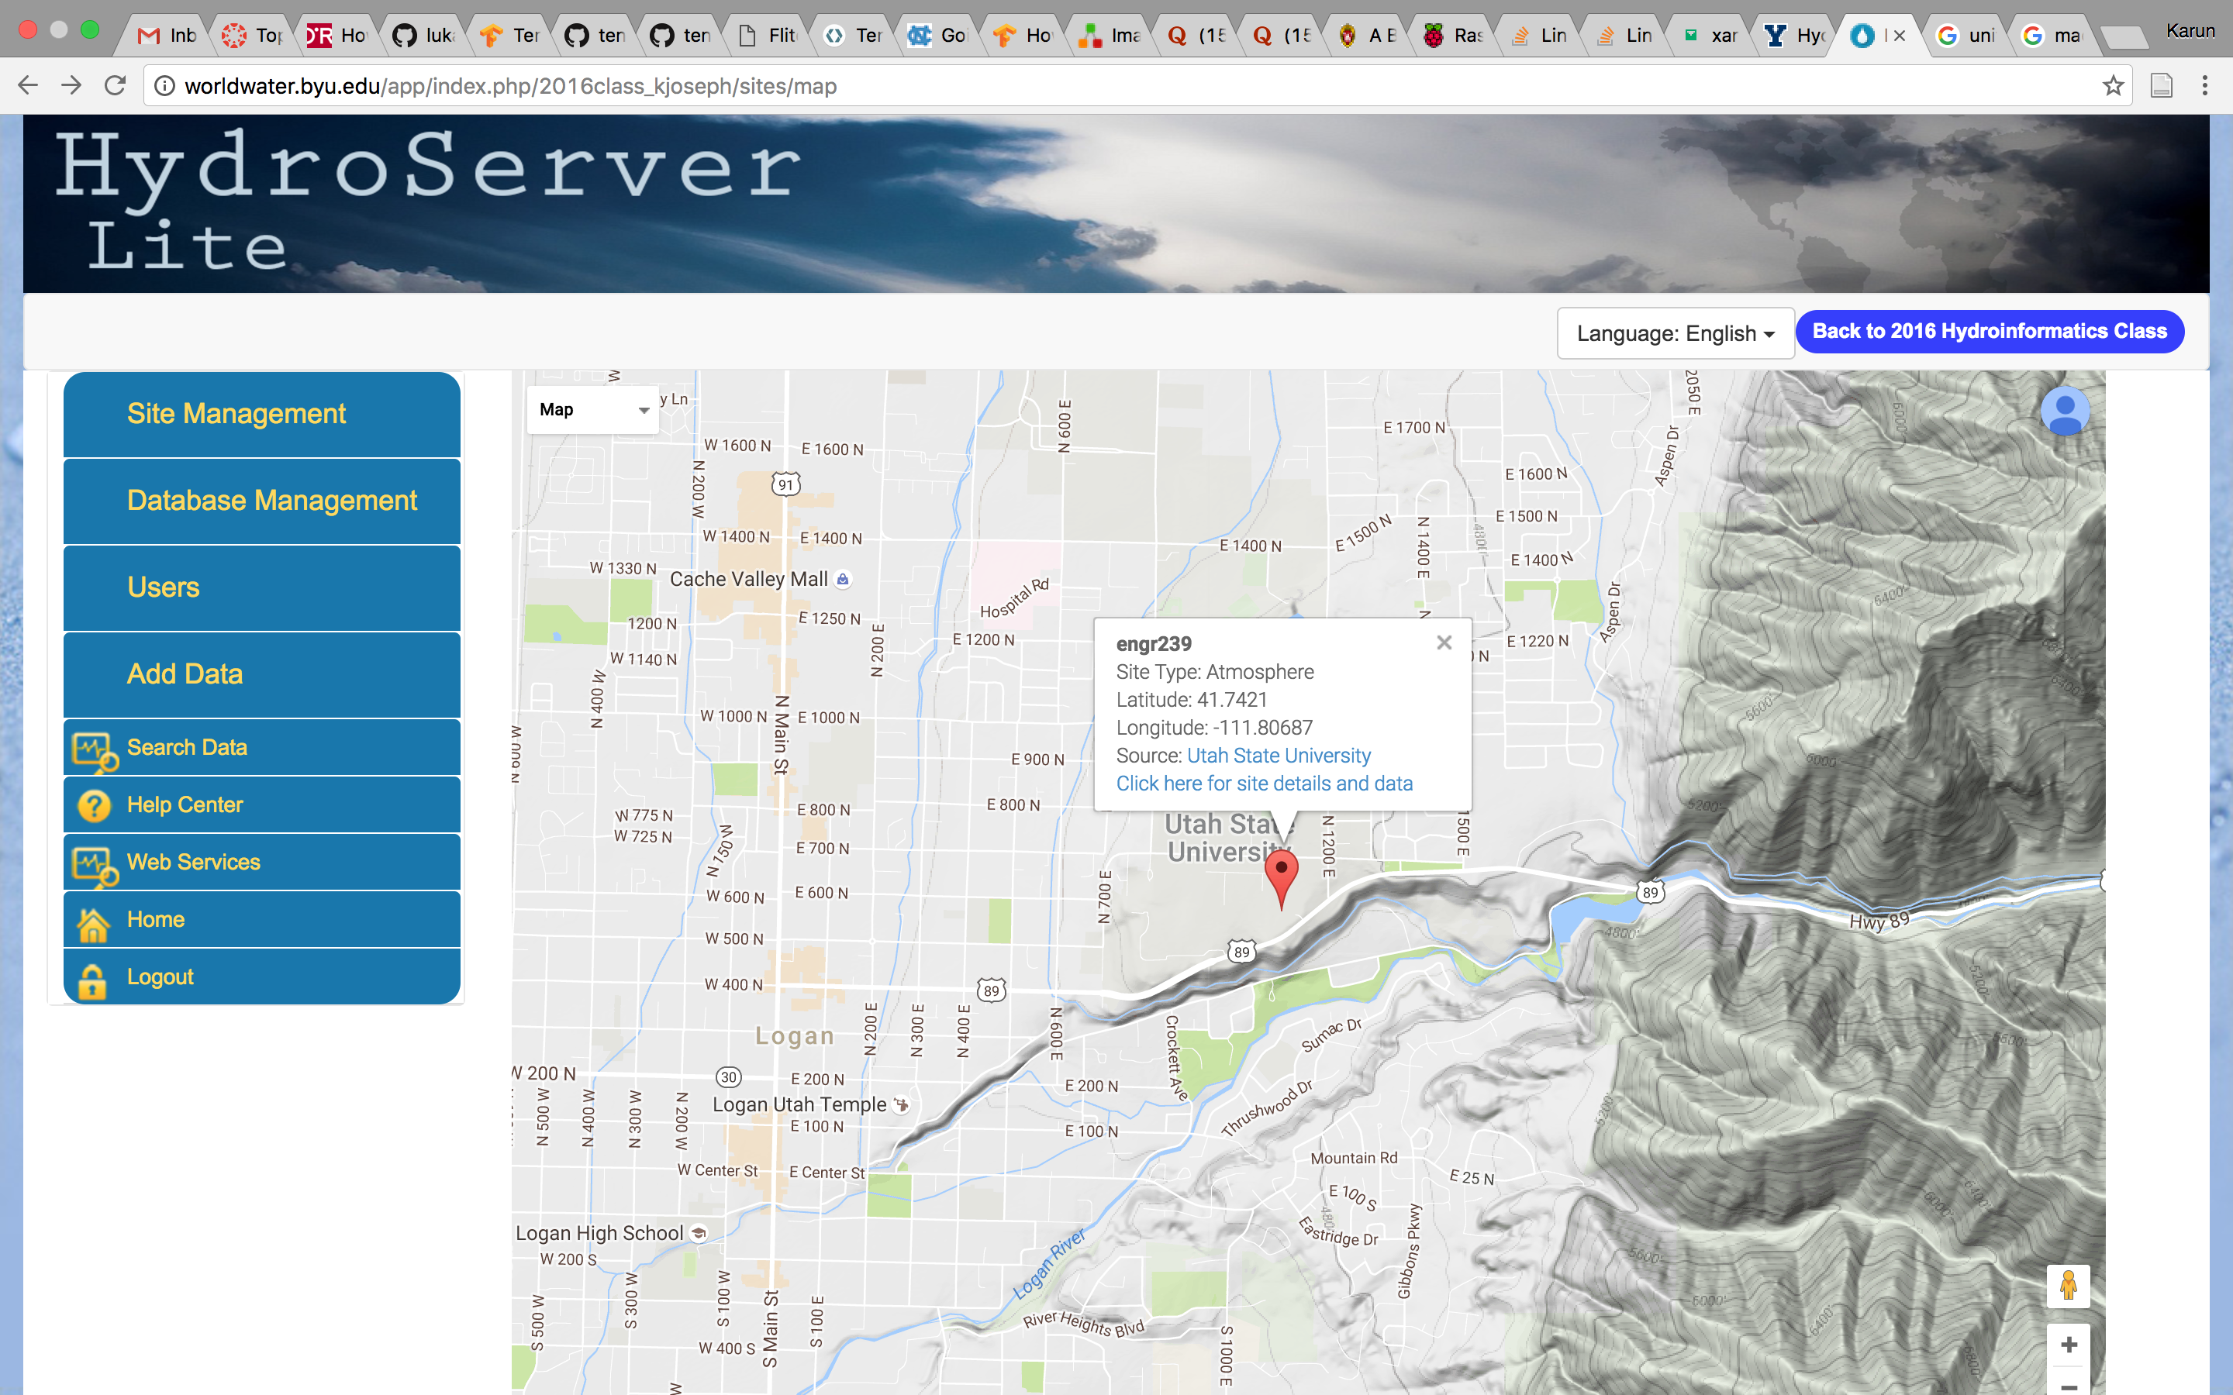

Fig. 2: Map view of location of site at ENGR 239, Utah State University, Logan, UT

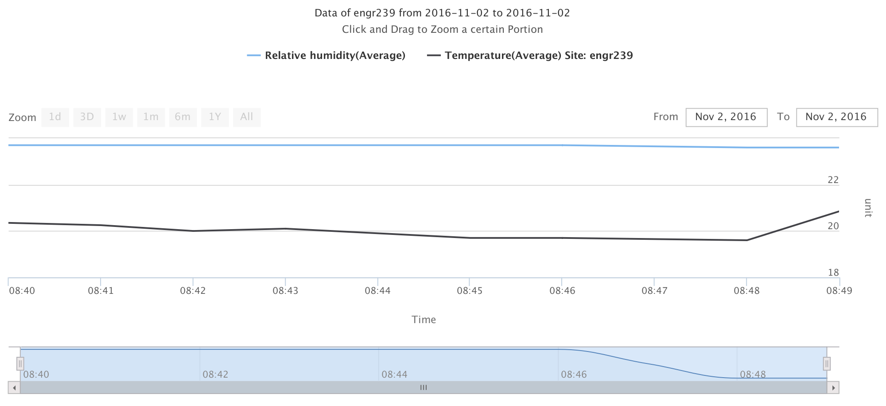

Fig. 3: Time series plot of measured temperature and relative humidity at ENGR 239, Utah State University, Logan, UT

Appendix B: Tables

|  |  |  |
| --- | --- | --- |
| Time | Temperature (degree Celsius) | Relative humidity (%) |
| 11/02/2016 08:40 | 20.35 | 23.7 |
| 11/02/2016 08:41 | 20.25 | 23.7 |
| 11/02/2016 08:42 | 20 | 23.7 |
| 11/02/2016 08:43 | 20.1 | 23.7 |
| 11/02/2016 08:44 | 19.9 | 23.7 |
| 11/02/2016 08:45 | 19.7 | 23.7 |
| 11/02/2016 08:46 | 19.7 | 23.7 |
| 11/02/2016 08:47 | 19.65 | 23.65 |
| 11/02/2016 08:48 | 19.6 | 23.6 |
| 11/02/2016 08:49 | 20.85 | 23.6 |

Table 1: Temperature and relative humidity data values collected using Arduino and AM2302 at ENGR 239, Utah State University, Logan, UT